Find out more about traditional seafaring, maritime heritage and boatbuilding

Sail Training Ireland
Sail Training Ireland is a charity who funds the development of young people from all backgrounds and all abilities on the island of Ireland by giving them the opportunity to participate on voyages on sailing vessels.

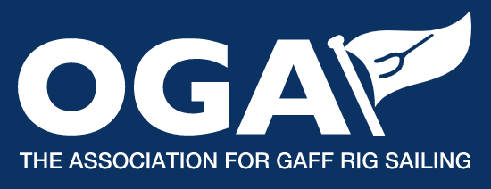  Old Gaffers Association  Formed in 1963. They work to encourage interest in gaff, lug and spritsail rig but welcome all types of boats and their owners as long as they share their enthusiasm for those traditional rigs. |  | 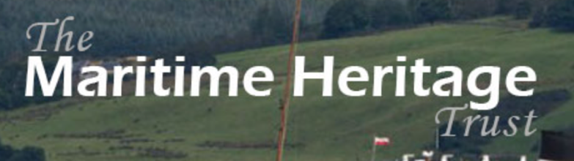  The Maritime Heritage Trust  The Maritime Heritage Trust aim is to make more people aware, care for and share our rich maritime heritage in all its dimensions– physical, cultural, social and environmental.
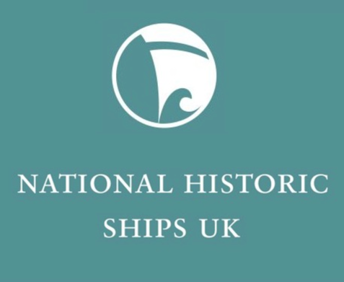  National Historic Ships UK  National Historic Ships UK is a government funded, independent organisation which gives objective advice to UK governments and local authorities, funding bodies, and the historic ships sector on all matters relating to historic vessels in the UK. |  | Royal Yachting Association  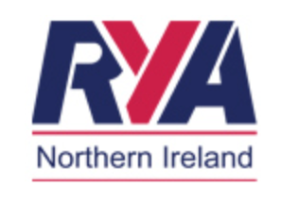  The Royal Yachting Association is the national governing body for dinghy, motor and sail cruising, all forms of sail racing, RIBs and sportsboats, windsurfing and personal watercraft, and is a leading representative body for inland waterways cruising in the UK.

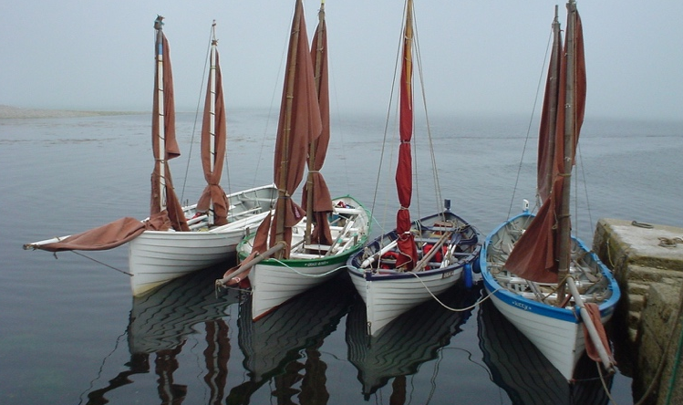  Traditional Yawl and Drontheim Society | 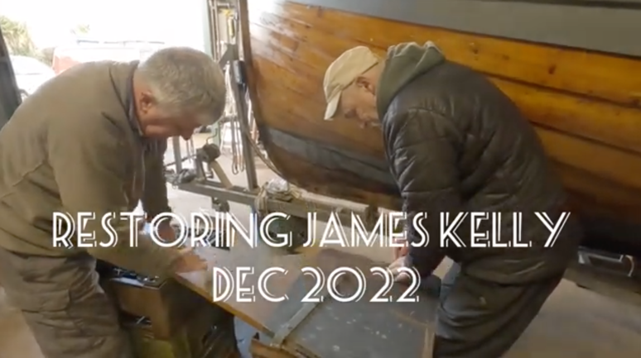  Restoring Drontheim James Kelly
Facebook Group | Video by David Poots, uploaded 10/12/22
The Coast Office | Located in Portballintrae  Their ‘Causeway Challenges’ project consists of water sports and maritime pursuits as a solution to health, wellbeing and understanding development in NI communities.

